**Object Oriented Programming**

**Assignment # 3**

**Name:** Muhammad Suhaib Salman

**Roll#:** 200768

**Class: BEEE-3A**

**Source Code**

#include <iostream>

using namespace std;

class Vehicle

{

protected:

string cost,number_people;

string colour,dimension;

void input()

{

cin.ignore();

cout<<"\n\nEnter cost: ";

getline(cin,cost);

cout<<"\nEnter number of people that can travel in the vehicle: ";

getline(cin,number_people);

cout<<"\nEnter dimension: ";

getline(cin,dimension);

cout<<"\nEnter colour: ";

getline(cin,colour);

}

void display()

{

cout<<"\nThe cost is "<<cost<<endl;

cout<<"\nThe number of people that can travel are "<<number_people<<endl;

cout<<"\nThe dimension is "<<dimension<<endl;

cout<<"\nThe color is "<<colour<<endl;

}

};

///////////////////////////////////////////////////////////////////////////

class Car : public Vehicle

{

protected:

string transmission_type, back_cam_type;

void input()

{

Vehicle::input();

cout<<"\nEnter transmission type of the vehicle: ";

getline(cin,transmission_type);

cout<<"\nEnter the type of back camera: ";

getline(cin,back_cam_type);

}

void display()

{

Vehicle::display();

cout<<"\nTransmission type of the vehicle: ";

cout<<"\nThe type of back camera: "<<endl;

}

};

class Van : public Car

{

string seats,wheeler,van_type;

public:

void input()

{

Car::input();

cout<<"\nIs your Van a 4 wheeler or 2 wheeler: ";

getline(cin,wheeler);

cout<<"\nEnter number of seats: ";

getline(cin,seats);

cout<<"\nEnter the type of van: ";

getline(cin,van_type);

}

void display()

{

Car::display();

cout<<"\nThis van is a "<<wheeler<<endl;

cout<<"\nThe number of seats in this car are "<<seats<<endl;

cout<<"\nThe type of the van is "<<van_type<<endl;

}

};

class Truck : public Car

{

string load,truck_type;

public:

void input()

{

Car::input();

cout<<"\nEnter maximum load capacity of the truck in kilos: ";

getline(cin,load);

cout<<"\nEnter the truck type: ";

getline(cin,truck_type);

}

void display()

{

cout<<"\nThe details of the truck are: "<<endl;

Car::display();

cout<<"\nThe maximum capacity of the truck is "<<load<<endl;

cout<<"The type of truck is "<<truck_type<<endl;

}

};

/////////////////////////////////////////////////////////////////////////////

class Boat: public Vehicle

{

protected:

string beam,air_draft,complement;

void input()

{

Vehicle::input();

cout<<"\nEnter beam: ";

getline(cin,beam);

cout<<"\nEnter air draft: ";

getline(cin,air_draft);

cout<<"\nEnter the maximum number of people that are required to operate the boat: ";

getline(cin,complement);

}

/*

Beam – The width of the widest point of the boat

Draft – The distance between the keel of the boat and the waterline; indicates the minimum depth of water the vessel needs to float

Air draft – The distance between the ship's waterline and the highest point of the boat; indicates the distance the vessel can safely pass under

Complement – The full number of people necessary to operate a ship, not counting any passengers

*/

void display()

{

Vehicle::display();

cout<<"\nThe beam of the boat is "<<beam<<endl;

cout<<"The air draft of the boat is "<<air_draft<<endl;

cout<<"The complement of the boat is "<<complement<<endl;

}

};

class Sailing_boat: public Boat

{

string sailing_boat_type;

public:

void input()

{

Boat::input();

cout<<"\nPlease enter the type of sailing boat:";

getline(cin,sailing_boat_type);

}

void display()

{

Boat::display();

cout<<"\nThe type of sailing boat is "<<sailing_boat_type<<endl;

}

};

class Yatchet: public Boat

{

string turbo_type,racing;

public:

void input()

{

Boat::input();

cout<<"\nPlease enter the turbo type of the motor: ";

getline(cin,turbo_type);

cout<<"\nIs your yachet a racing yachet? ";

getline(cin,racing);

}

void display()

{

Boat::display();

cout<<"\nTurbo type: "<<turbo_type<<endl<<"Racing yachet: "<<racing<<endl;

}

};

class Aircraft : public Vehicle

{

string max_altitude,fuel_capacity,autopilot;

public:

void input()

{

Vehicle::input();

cout<<"\nPlease enter the maximum altitude that can be achieved by the aircraft: ";

getline(cin,max_altitude);

cout<<"\nPlease enter the fuel capcity: ";

getline(cin,fuel_capacity);

cout<<"\nDoes your aircraft have autopilot? ";

getline(cin,autopilot);

}

void display()

{

Vehicle::display();

cout<<"\nMax limit of altitude: "<<max_altitude<<endl<<"\nAutopilot support: "<<autopilot<<endl<<"Fuel capacity: "<<fuel_capacity<<endl;

}

};

class helicopter: public Aircraft

{

string tail_rotor_type,rotor_head_type;

public:

void input()

{

Aircraft::input();

cout<<"\nPlease enter the tail rotor type: ";

getline(cin,tail_rotor_type);

cout<<"\nPlease enter the rotor head type: ";

getline(cin,rotor_head_type);

}

void display()

{

Aircraft::display();

cout<<"Tail Rotor Type: "<<tail_rotor_type<<endl;

cout<<"Rotor Head Type: "<<rotor_head_type<<endl;

}

};

class UFO : public Aircraft

{

string teleportation_ability,solar_gun,shrink_beam;

public:

void input()

{

Aircraft::input();

cout<<"\nDoes your UFO have teleportation ability: ";

getline(cin,teleportation_ability);

cout<<"\nDoes your UFO have solar gun: ";

getline(cin,solar_gun);

cout<<"\nDoes your UFO have shrink beam: ";

getline(cin,shrink_beam);

}

void display()

{

Aircraft::display();

cout<<"Solar Gun: "<<solar_gun<<endl<<"Shrink Beam: "<<shrink_beam<<endl<<"Teleportation Ability: "<<teleportation_ability<<endl;

}

};

int main()

{

cout<<"\nWhat type of vehicle do you want?"<<endl;

cout<<"Press 1 for Van"<<endl<<"Press 2 for Truck"<<endl;

cout<<"Press 3 for Sailing Boat"<<endl<<"Press 4 Yachet"<<endl;

cout<<"Press 5 for helicopter"<<endl<<"Press 6 for UFO"<<endl;

int x=0;

cin>>x;

if (x==1)

{

Van v;

v.input();

v.display();

}

else if( x==2)

{

Truck t;

t.input();

t.display();

}

else if (x==3)

{

Sailing_boat s;

s.input();

s.display();

}

else if (x==4)

{

Yatchet y;

y.input();

y.display();

}

else if (x==5)

{

helicopter h;

h.input();

h.display();

}

else if (x==6)

{

UFO u;

u.input();

u.display();

}

else

{

cout<<"\nPlease enter a correct value!"<<endl;

}

}

**OUTPUT**

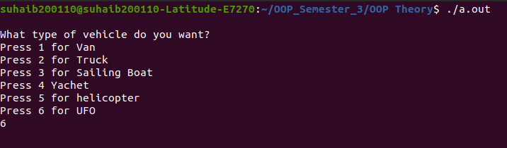

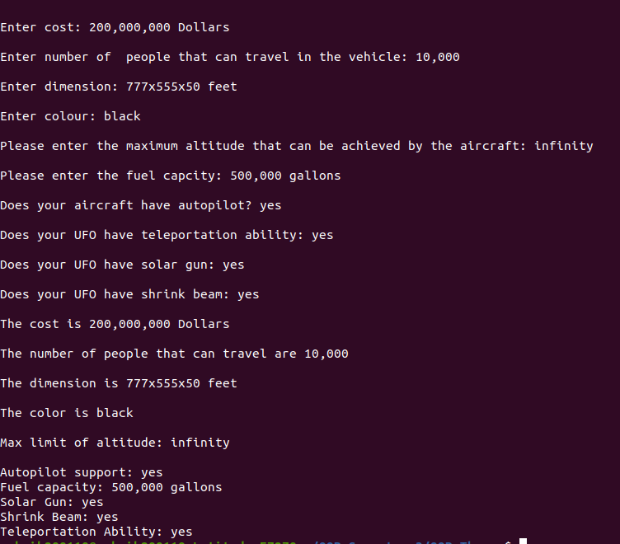

**Working:**

* Firstly I created a parent class Vehicle that contained the common features that were required in its child classes. There was an input function and a display function in the vehicle class.
* Then I derived three classes from the vehicle class. In these classes I described some features of that class and then asked the user to enter specify these features and this class also contained a display function. Thus, all the derived classes had two functions that were input and display function.
* After that I further derived two more classes from each class that was derived from the vehicle class.
* These classes also had the input and display function.
* I used public inheritance in all the derived classes.
* In derived class, in each function I called a function from its parent class for example in input function of UFO class I firstly called the input function of Aircraft class and in Aircraft’s class input function I called the input function of the Vehicle class.